**Nltk installation link :-** <https://www.guru99.com/download-install-nltk.html>

**TextBlob** module is a **Python** (2 and 3) library for processing textual data. It provides a simple API for diving into common natural language processing (NLP) tasks such as part-of-speech tagging, noun phrase extraction, sentiment analysis, classification, translation, and more.

http://python.org/about/success/.

Software’s and libraries to learn Machine Learning:-

Python: 2.7 or higher

NumPy: 1.6.2 or higher

SciPy: 0.11 or higher

Scikit-learn: 0.13 or higher

Use below highlighted command to download & install libraries.

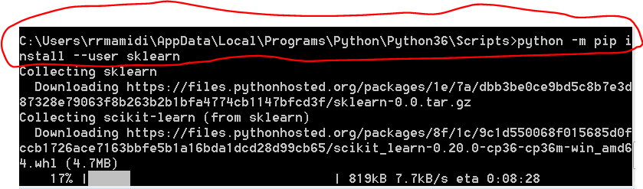

Useful links:-

<https://machinelearningmastery.com/machine-learning-in-python-step-by-step/>

<https://machinelearningmastery.com/start-here/#timeseries>

<https://archive.ics.uci.edu/ml/datasets/Iris>

<https://www.youtube.com/watch?v=3mHy4OSyRf0> for LDA overview

To Build Topic Model we need below libraries,

1. Gensim
2. Nltk
3. Useful link for nltk (http://www.nltk.org/ )
4. Nltk installed details(C:\Users\rrmamidi\AppData\Roaming\nltk_data)
5. **Book for reference (**[**http://www.nltk.org/book/**](http://www.nltk.org/book/)**)**
6. **Use below command to check what all installed for nltk. It gives brief description about those in a table format.**



1. http://www.nltk.org/api/nltk.tokenize.html#nltk.tokenize.treebank.TreebankWordDetokenizer.CONTRACTIONS2
2. How to, for each module in nltk (<http://www.nltk.org/howto/>)
3. NLP (or) NLTK book for reference (<http://www.nltk.org/book/> )



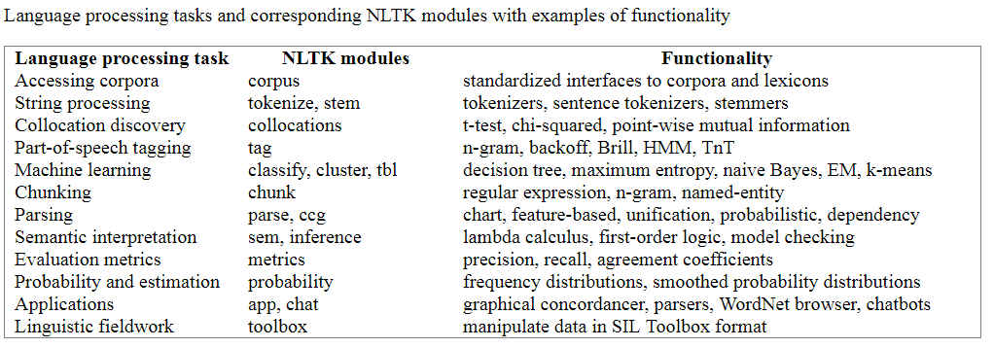

Use below for help

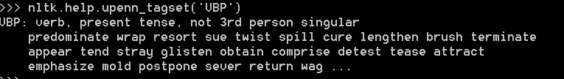

For image reading ‘Mahotas’ library along with ‘imread’ library of machine learning.

‘Jug’ library used for managing big data.

<https://www.youtube.com/watch?v=hd1W4CyPX58> for iris dataset

<http://scikit-learn.org/stable/modules/neighbors.html> for KNN(K Nearest Neighbor algorithm and how to use)

<http://scikit-learn.org/stable/modules/generated/sklearn.neighbors.kNeighborsClassifier.html>

<https://www.dataschool.io/15-hours-of-expert-machine-learning-videos/> for statistical learning also known as machine learning